Instruction Manual
DDS-307A
DDS-307
DDS-11A
Conductivity Meter

Form 3:Approximate Concentration of KCL Solution and Relationship of it with Conductivity Value

Temp. Approximate concentration (mol/L) | 15.0℃ | 18.0℃ | 20.0℃ | 25.0℃ | 30.0℃
1 | 12120 | 97800 | 101700 | 111310 | 131100
0.1 | 10455 | 11163 | 11644 | 12852 | 15353
0.01 | 1141.4 | 1220.0 | 1273.7 | 1408.3 | 1687.6
0.001 | 118.5 | 126.7 | 132.2 | 146.6 | 176.5
8. Complete set of Meter
A set of accessories, refer to packing list shipped with the meter.
Model | Configuration
DDS-307A | DJS-1CT Conductivity probe(Platinum-black) 1pc  9V Power supply 1pc  Electrode Holder 1pc
DDS-307 | DJS-1C Conductivity probe(Platinum-black) 1pc  9V Power supply 1pc  Electrode Holder 1pc
DDS-11A | DJS-1C Conductivity probe(Platinum-black) 1pc  9V Power supply 1pc  Electrode Holder 1pc

9. Ordering Notes
- The meter is equipped with platinum black electrode (K=1.00)
- Refer to chapter 4.5 in this manual and choose proper conductivity probe according to measuring range of conductivity.

Contents
- General
- Specifications
- Structure
- Operation
- Maintenance
- The cleaning and storage of conductivity electrode
- Appendix
- Complete set of Meter
- Notes for ordering

1. General
There are three models of Laboratory Conductivity Meters that are DDS-307A,DDS-307 and DDS-11A. It is a necessary meter for measuring conductivity in solution. It adopts new design such as LCD segment display and novel appearance. It is widely used in petrochemical industry, biological medicine, sewage water treatment, environmental monitoring, mining metallurgy, scientific research and university. In addition, with conductivity probe of suitable constant it can be used to measure the conductivity of the pure or ultra pure water in semiconductor plant, nuclear energy industries, and power station.

Its feature:
- Adopts large LCD screen
- Double display conductivity and temperature or TDS and temperature
- Compensate cell constant
- Compensate temperature by manually or automatically.

2. Specifications

2.1 Measuring range

Model | Conductivity range( μS/cm)
DDS-307A | - Conductivity :0.000μS/cm～199.9ｍS/cm  - TDS：(0.00mg/L～1999)mg/L  - Temp：(0.0～60.0)℃
DDS-307 | - Conductivity :0.000μS/cm～199.9ｍS/cm  - TDS：(0.00mg/L～1999)mg/L
DDS-11A | - Conductivity :0.000μS/cm～199.9ｍS/cm

Cell Constant Recommend

Cell constant cm-1 | Conductivity rangeμS/cm
0.01 | 0～2.000μS/cm
0.1 | 2～20.00μS/cm
1 | 20μS/cm～10.00mS/cm
10 | （10～199.9）mS/cm
- To read the conductivity value Kc;
- To calculate the cell constant J: J=K/Kc
In which: K is standard conductivity of solution (refer to Form 3)
7.1.2 Calibrate Standard Probe
Choose appropriate standard solution (see Form 1), preparation method (see Form 2), the relationship form of standard solution and conductivity (see Form 3) according to cell constant:
- To choose a standard probe with known constant. (Set the constant as
Jstandard);
- To choose appropriate standard solution (see Form 1), preparation method (see Form 2), the relationship form of standard solution and conductivity (see Form3)
- To rinse probe with unknown constant (Set it as J1) and standard probe with distilled water, immerse these two probes in the solution with same depth;
- To connect the probe with conductivity meter in order and measure K1 and Kstandard;
- To calculate the cell constant J1 with the following formula. :
J1 = Jstandard X Kstandard / K1
In which: K1 is conductivity value of unknown constant
Kstandard is conductivity value of standard probe.

Form 1: KCL Standard Solution for Conductivity Probe Constant
Cell Constant(l/cm) | 0.01 | 0.1 | 1 | 10
Approximate concentration of KCL solution (mol/L) | 0.001 | 0.01 | 0.01 or 0.1 | 0.1 or 1

Form 2: Composition of Standard Solution
Approximate concentration(mol/L) | Capacity concentration KCL (g/L) solution  (20℃ in air)
1 | 74.2650
0.1 | 7.4365
0.01 | 0.7440
0.001 | Dilute 100mL solution of 0.01mol/L to 1L.

5.3 To avoid pollution when measuring ultra pure water. It is better to measure with sealing, flowing method and ensure chosen correct conductivity probe
5.4 TDS of the meter will be displayed with the formula ‘TDS:
Conductivity=1:2’
5.5 To guarantee measuring accuracy, probes should be rinsed with deionized
water(or distilled water) of <0.5μS/cm for two times. And then rinse the
probe with sample solution.
5.6 Probe sockets must be prevented from moisture, to avoid any unnecessary
error.
6. The clearance and storage of conductivity electrode
6.1 Store Conductivity Probe
- To store the probe (out of service for a long time) in dry place;
- To immerse the probe in distilled water for several hours before using;
- To store the probe (often used) in distilled water.
6.2 Clean Conductivity Probe
- To wash polycyclic pollutant on the probe with warm detergent or alcohol;
- To wash calcium or magnesium deposit on the electrode with 10%citric acid;
- For bright probe, wash it with soft brush. But there should not be scratch on the electrode surface. It is forbidden to clean the surface of electrode with any hard ware, etc. Be carefully even in washing it with soft brush.
- For platinum black electrode, only wash it with chemistry method, or it will change platinum on electrode surface
7. Appendix
7.1 Calibrate cell constant
Every probe is labeled with cell constant before ex-factory. If user suspects cell constant is not correct, recalibrate it according to steps as follows:
7.1.1 Calibrate in Standard Solution
Choose appropriate standard solution (see Form 1), preparation method (see Form 2), the relationship form of standard solution and conductivity (see Form 3) according to cell constant:
- To connect the meter with conductivity probe and disconnect the ATC probe, adopt manual temperature setting. The manual temperature is set at 25℃, and the reading is conductivity value which does not have temperature compensation;
- To rinse conductivity probe with distilled water;
- To immerse conductivity probe into standard solution;
- To control the solution temperature at (25.0±0.1)℃;
- To immerse the probe into standard solution;

2.2 Temp compensation range: （0~60.0）℃ by manual or auto
2.3 Specification:
Item | Accuracy of electronic unit | Accuracy of the meter
DDS-307A | - Conductivity range::±1.0％(FS)  - TDS：±1.0％(FS)  - Temp：±0.3℃ | - Conductivity range::±1.5％(FS)  - Temp：±0.6℃
DDS-307 | - Conductivity range::±1.0％(FS)  - TDS：±1.0％(FS) | - Conductivity range::±1.5％(FS)
DDS-11A | - Conductivity range::±1.0％(FS) | - Conductivity range::±2.0％(FS)
2.4 Dimension: 1×b×h 280×200×80 mm
2.5 Weight：1.5kg
2.6．Normal operation conditions
- Ambient Temperature：(0~40)℃
- Relative humidity：<=85％
- Power supply：DC 9V/400mA
- No strong electromagnetic interference except the geomagnetic field.
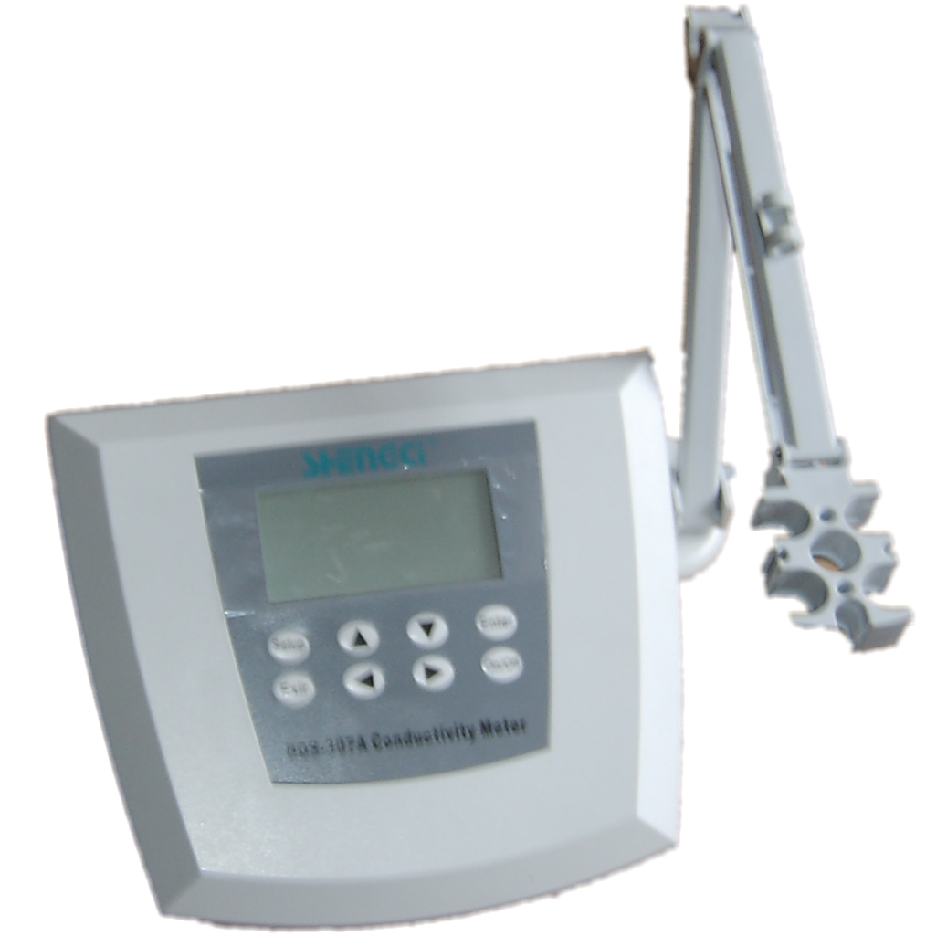
3. Structure
The front panel of the meter

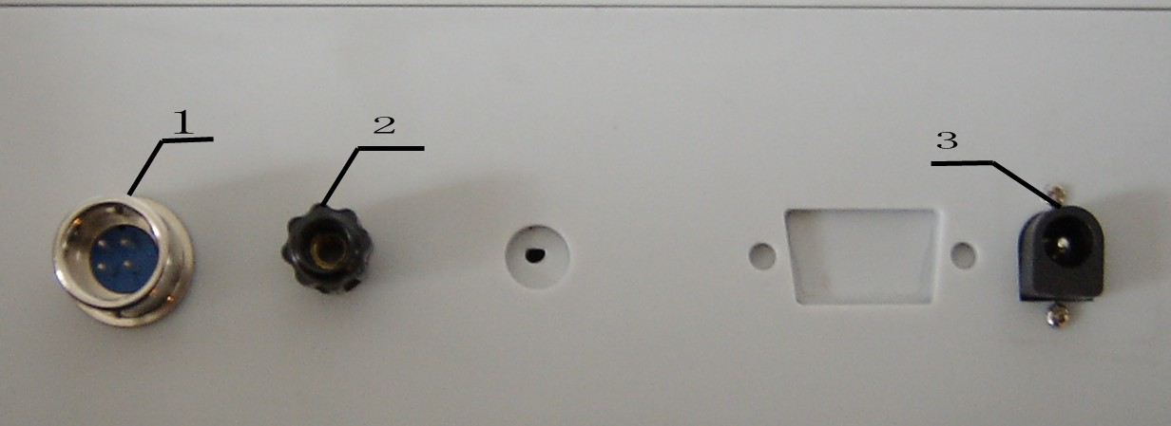
The rear view of meter
1 ─MEAS: Conductivity probe
2 ─ Grounding
3 ─Power supply

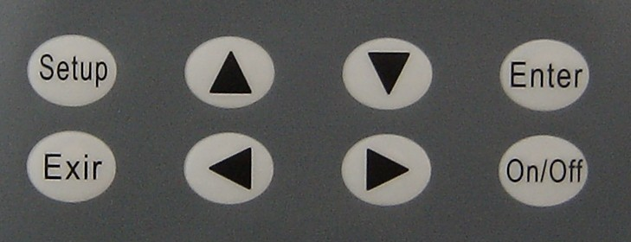
The keypad

Key | Function
Setup | To set cell constant and temperature value
On/Off | To turn on or off the meter
Exit | To return back last measurement state in the setting of constant and temperature
▲ | To switch between conductivity and TDS measurement state  To increase the reading
▼ | To switch between conductivity and TDS measurement state  To reduce the reading
 | To down the reading
 | To up the reading
Enter | To confirm the last operating
4. Operation
4.1 Preparing before Startup
- Insert the multifunction electrode stand into the electrode stand socket and screw it tightly.
- Install the conductivity probe onto the electrode stand.
- Rinse the probe with distilled water.
4.2 Operating
- To connect the meter with power line;
- To press On/Off key;
- To enter measuring state.
- Heat up the meter for 30 minutes to do measurement.
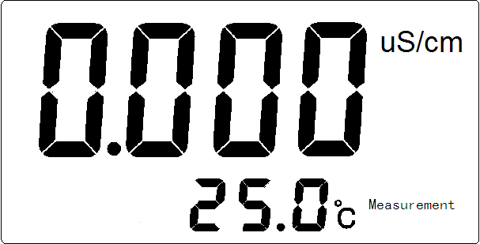
In the measuring state:

- To press ▲ or ▼ key to switch conductivity display and TDS display;
- To press Setup key to set up temperature value and cell constant;

4.6 Measuring
4.6.1Measuring conductivity
After the setting up as described in chapter 4.3~4.4,
the meter can measure conductivity of sample.
(Display as the left)
In the state of measurement, press ▲ or ▼ key to enter
into measurement conductivity state.
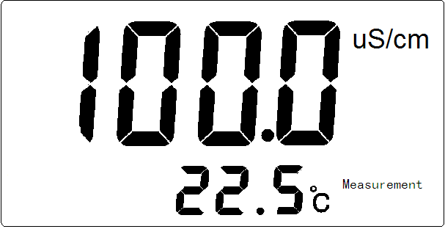
- To connect the meter with conductivity probe;
- To rinse the probe tip with distilled water and sample;
- To immerse the conductivity probe into sample;
- To stir the sample evenly with glass bar.
- To read the conductivity value
If the sample temperature is 22.5℃ and conductivity value
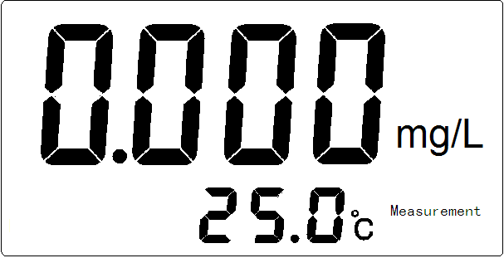
is 100.0uS/cm, the meter displays as left.
4.6.2 Measuring TDS
After the setting up as described in chapter4.3~4.5,
the meter can measure TDS of sample:
(Display as the left)
In the state of measurement, press ▲ or ▼ key to enter
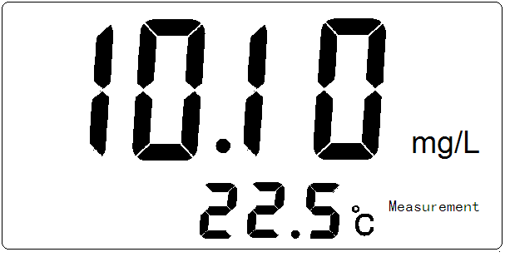
into measurement conductivity state.
- To connect the meter with conductivity probe;
- To rinse the probe tip with distilled water and sample;
- To immerse the conductivity probe into sample;
- To stir the sample evenly with glass bar.
- To read the conductivity value
If the sample temperature is 22.5℃ and conductivity value
is 10.10mg/L, the meter displays as left.

Caution: If there are some mistakes in the meter, initialize the meter as following:
- To turn off the meter;
- To press ◄, ► and On/Off key at the same time;

5. Maintenance:
5.1 The conductivity probe must be immersed into distilled water for several hours before using. Store conductivity probes in the distilled water.

5.2 To guarantee the measuring accuracy of the meter, recalibrate the cell constant before using. Calibrate cell constant at regular intervals.

4.4.4 Setting Cell Constant Value as ‘10’
In the state of the measurement
- To press Setup key;
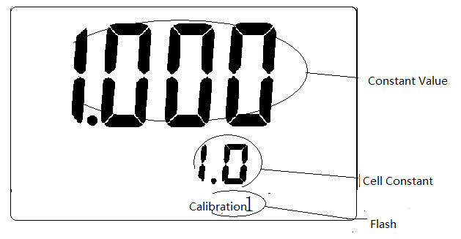
- To press ▲ or ▼ key

The meter will display as the left:
- To press Setup key;

The Calibration1 will be stop flashing
- To press ▲ or ▼ key

The ell constant value will be displayed among
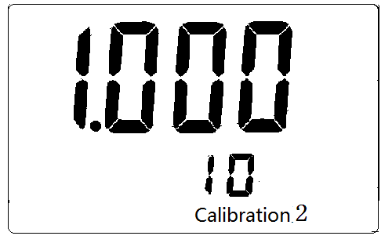
10,1, 0.1 and 0.01.
- To select the cell constant is 10
- To press Enter key

The meter will display as left
- To press Setup key again;
- To move the cursor by pressing ◄or ► key;
- To increase or reduce the reading by pressing ▲ or ▼ key

If the cell constant is marked as 10.01, select the
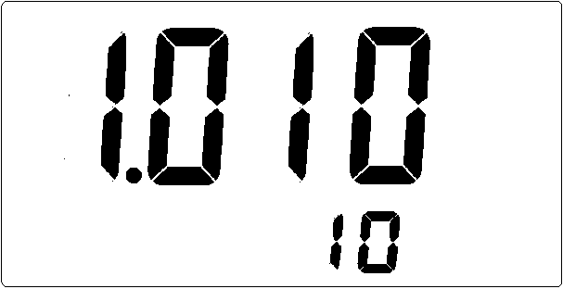
constant value is 1.010 by pressing ▲ or ▼ key.
- To save the data by pressing Enter key;
- To finish setting the cell constant and constant.
(The cell constant is that the product of upper
group value multiply by following group value)
- Press Exit key to return back in measuring state.

4.5 Setting TDS factor
The default TDS factor is 0.5. The TDS factor is not set by user in normal; to
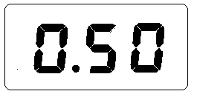
modify TDS factor in the measurement as following:
- To press Setup key;
- To press▲ or ▼ key and the meter will display

- To press Setup key again, the left reading will flash;
- To move the cursor by pressing ◄or ► key;
- To increase or reduce the reading by pressing ▲ or ▼ key
- To save the date by pressing Enter key;
- To return back the measurement state by pressing Exit key

4.3 Setting temp value and temp coefficient
4.3.1 Setting temp value
 | Setup temp value | Why
DDS-307A | Not | With ATC probe
DDS-307 | Yes | Without ATC probe
DDS-11A | Yes | Without ATC probe

- To press Setup key in the measurement state;
- To press Setup key again, the left reading will flash;
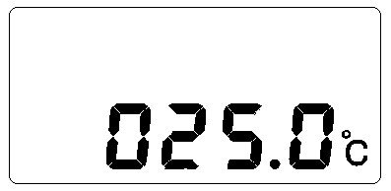
- To move the cursor by pressing ◄or ► key;
- To increase or reduce the reading by pressing ▲ or ▼ key
- To save the date by pressing Enter key;
- To return back the measurement state by pressing Exit key
4.3.2 Setting temp coefficient
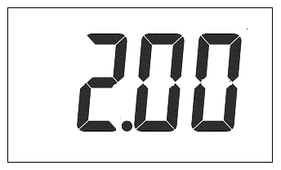
The default temperature coefficient is 2%. The temperature coefficient is not set by user in normal; to modify temperature coefficient in the state of measurement as following:
- To press Setup key;
- To press ▲ or ▼ key and the meter will display
- To press Setup key again, the left reading will flash;
- To move the cursor by pressing ◄or ► key;
- To increase or reduce the reading by pressing ▲ or ▼ key
- To save the date by pressing Enter key;
- To return back the measurement state by pressing Exit key
4.4 Setting Cell Constant and Constant
To Set up cell constant before using. There are four types cell constant of conductivity probe: 0.01, 0.1, 1.0 and 10. The detailed cell constant value will be labeled on each conductivity probe. User can set up according to cell constant marked.
4.4.1 Setting Cell Constant Value as ‘1’
In the state of the measurement
- To press Setup key;
- To press ▲ or ▼ key
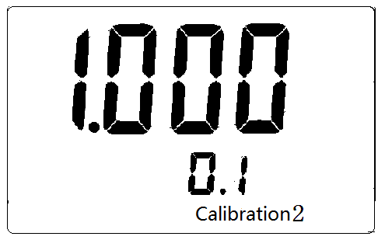
The meter will display as the left:
- To press Setup key;
The Calibration1 will be stop flashing
- To press ▲ or ▼ key

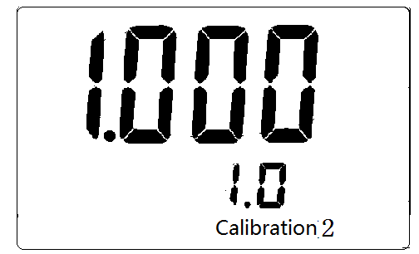
The ell constant value will be displayed among 10,1, 0.1 and 0.01.
- To select the cell constant is 1.0
- To press Enter key
The meter will display as left
- To press Setup key again;
- To move the cursor by pressing ◄or ► key;
- To increase or reduce the reading by pressing ▲ or ▼ key

If the cell constant is marked as 1.010, select the
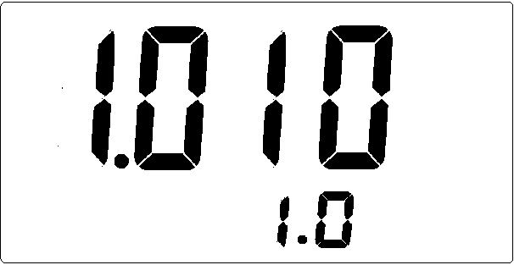
Constant value is 1.010 by pressing ▲ or ▼ key.
- To save the data by pressing Enter key;
- To finish setting the cell constant and constant.
(The cell constant is that the product of upper
group value multiply by following group value)
- Press Exit key to return back in measuring state.

4.4.2Setting Cell Constant Value as ‘0.1’
In the state of the measurement
- To press Setup key;
- To press ▲ or ▼ key
The meter will display as the left:
- To press Setup key;
The Calibration1 will be stop flashing
- To press ▲ or ▼ key

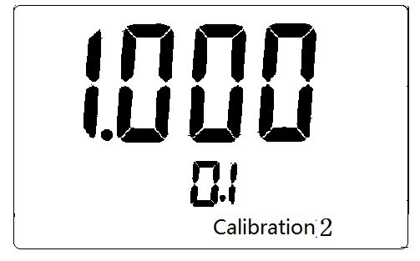
The ell constant value will be displayed among 10,1, 0.1 and 0.01.
- To select the cell constant is 0.1
- To press Enter key

The meter will display as left
- To press Setup key again;
- To move the cursor by pressing ◄or ► key;
- To increase or reduce the reading by pressing ▲ or ▼ key
If the cell constant is marked as 0.1010, select the
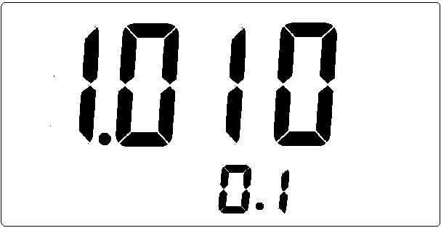
constant value is 1.010 by pressing ▲ or ▼ key.
- To save the data by pressing Enter key;
- To finish setting the cell constant and constant.
(The cell constant is that the product of upper
group value multiply by following group value)
- Press Exit key to return back in measuring state.

4.4.3 Setting Cell Constant Value as ‘0.01’
In the state of the measurement
- To press Setup key;
- To press ▲ or ▼ key

The meter will display as the left:
- To press Setup key;

The Calibration1 will be stop flashing
- To press ▲ or ▼ key

The ell constant value will be displayed among 10,1, 0.1 and 0.01.
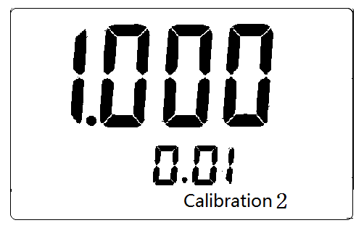
- To select the cell constant is 0.01
- To press Enter key

The meter will display as left
- To press Setup key again;
- To move the cursor by pressing ◄or ► key;
- To increase or reduce the reading by pressing ▲ or ▼ key

If the cell constant is marked as 0.0101, select the
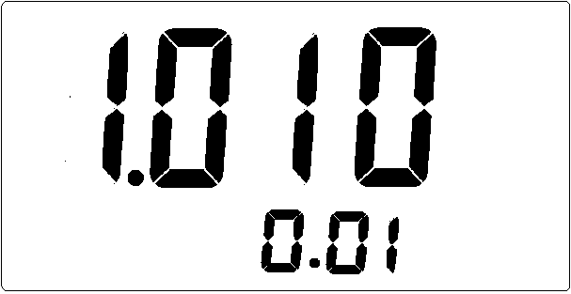
constant value is 1.010 by pressing ▲ or ▼ key.
- To save the data by pressing Enter key;
- To finish setting the cell constant and constant.
(The cell constant is that the product of upper
group value multiply by following group value)
- Press Exit key to return back in measuring state.

